**SOLUTION ARCHITECTURE:**

* **Body movement patterns and connecting cameras to “ARTIFICIAL INTELLIGENCE” system we can devise an underwater pool safety system that reduces the risk of drowning.**
* **AS a POC we make use of one camera that streams the video underwater and analyzes the position of swimmers to access probability of drowning.**

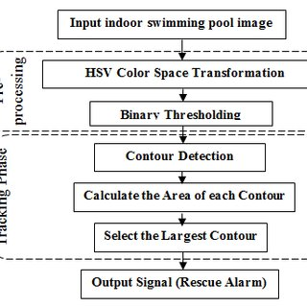

**MONITOR:**

* **VirtualEye cameras “detect the movements” of every swimmers in the pool.**

**DETECT:**

* **The “Artificial intelligence” of the VirtualEye software analyzes the images acquired by the cameras in real time and “Identifies situations of danger or drowning”.**

**ALERT:**

* **Lifeguards are promptly alerted to danderous situations through smartwatch technology or other signalling devices.**
* **“The image and exact position of the swimmer” in distress allows lifeguards to intervence immediately.**